Filed by American Water Works Company, Inc.

pursuant to Rule 425 under the Securities Act of 1933

and deemed filed pursuant to Rule 14a-6

under the Securities Exchange Act of 1934

Subject Company: Essential Utilities, Inc.

Commission File No.: 001-06659

Date: May 29, 2026

The following article regarding the merger between American Water Works Company, Inc. and Essential Utilities, Inc. was published online by The Philadelphia Inquirer on May 29, 2026.
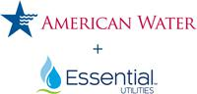

CHANGEMAKER SPOTLIGHT

PARTNER CONTENT

American Water and Essential Utilities Leaders on the Mission of Clean Water

Chris Franklin, the chairman and CEO of Essential Utilities, and John Griffith, the president and CEO of American Water, discuss legacy, infrastructure, and their upcoming merger.
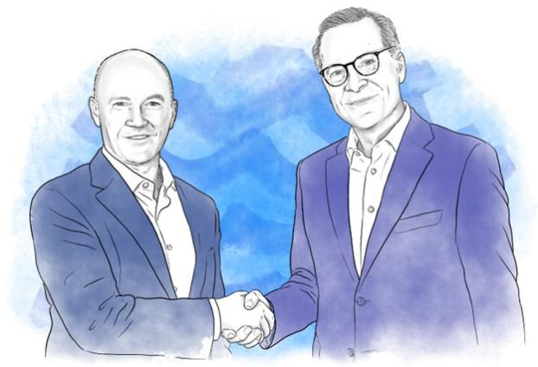

P. Binkley / Illustration

by Lucy Danziger

The recently announced merger of American Water and Essential Utilities, which is expected to close by the end of the first quarter of 2027, will create one of the nation’s leading regulated utilities. “One of the many reasons I like the idea of this merger is that the cultures of the two companies are so similar,” Chris Franklin, the chairman and CEO of Essential Utilities, said. “I am very confident that the company I’ve worked for and led for 33 years is agreeing to merge with a like-minded organization that values their customers and provides them with high-quality service.”

Headquartered in Camden, N.J., the combined company will serve approximately 4.7 million customers across 17 states, with the Greater Philadelphia region comprising nearly 20% of its customers. The combined organization plans to invest $28 billion in improvements over the next five years, including pipe replacements and upgrades to aging treatment facilities, that will help to support reliable service and positively impact local economies.

In a joint interview, Franklin and American Water president and CEO John Griffith discussed the pressures facing the nation’s water systems, the need for major infrastructure investment, and what the merger could mean for Pennsylvania and South Jersey. “I want families who are customers today to know that our commitment to service will not be compromised when we are serving them together,” Franklin said.

Chris, Essential Utilities traces its roots in Philadelphia and the region to 1886. What responsibility does that legacy create for you as a leader?

Franklin: Both Essential and American Water are 140 years old, and each has a rich history of leaders who have made investments and improvements with quality as a core value. Now, it’s our turn to address the challenges of our time. The current leaders of our companies are incredibly talented and dedicated people, and I am confident they will raise our service and quality to new levels.

Between New Jersey and Pennsylvania, what’s called the Philly metro area, will be nearly 20% of the customers of the combined company. We are focused on the Philly metro area. While we don’t serve inside the city, we do serve the areas all the way around it and see the city as an integral part of our community.

Was there a moment in each of your careers when you realized how critical water infrastructure was?

Franklin: It wasn’t until I arrived at Philadelphia Suburban Water Co. in 1992 that I really gave it much thought. Like so many people, I turned my faucet on and clean water appeared. It was immediately evident to me that the company was running big plants, processing enormous amounts of water, and doing it with a team that had great dedication to their work. Our people

fill a very basic but important need — the delivery of safe, clean water. Most people never think about where it comes from or how it gets purified; they simply expect that when they turn on their faucet, pristine water arrives. It’s a huge responsibility that our people work to fulfill every hour of every day. Pretty quickly, I gained a healthy respect and appreciation for the company and its mission.

Griffith: Spending time in communities where we previously acquired systems that were so neglected. You look around, and it’s just not acceptable that people don’t have access to clean water and wastewater service.

“Our people fill a very basic but important need — the delivery of safe, clean water. Most people never think about where it comes from or how it gets purified; they simply expect that when they turn on their faucet, pristine water arrives. It’s a huge responsibility that our people work to fulfill every hour of every day.”

— Chris Franklin, Chairman and CEO, Essential Utilities

What keeps each of you in this business?

Franklin: Why do you stay at a company for 33 years? Because I truly believe in the company’s mission. I’m proud that we provide such high-quality water that nobody who drinks our water ever needs to doubt that their tap water is clean and safe enough to drink directly from the faucet. Additionally, we do the dirty work of treating wastewater and returning only clean, clear water back into the environment. It is very rewarding work!

Griffith: People at American Water, and I know it’s the same at Essential, feel an extraordinary amount of commitment to the mission in the work we do every day. I’m energized every morning by the work we do and the people I work with.

John, the country faces enormous water infrastructure challenges. How will this merger position the new company to address them more effectively?

Griffith: It’s difficult and expensive to replace water infrastructure. You’re digging up pipes under the ground, and you’re dealing with large-scale treatment operations. Because of these financial and operational challenges, it’s hard for municipal leadership to pull the trigger on needed capital investments, and these deferrals build up over decades. That’s especially true for small and midsize communities who don’t have a large customer base to spread the cost over. Eventually systems break down with very significant consequences. And that’s before you even talk about requirements like treating PFAS, the so-called “forever chemicals,” contamination, and cyber protection.

To do something as complex as delivering clean drinking water 24 hours a day, every day of the year, it takes a lot of operating and technical expertise. Having a large-scale operating platform is super helpful in this regard. It allows us to continue to invest in our people, training, and technology, and to procure equipment and supplies more cheaply. It also allows us to spread this cost over a bigger customer base, which benefits all of our customers. We want to be the leader in the country in delivering best-in-class water and wastewater service, and we believe the merger will help the company do that.

Chris, what would you want customers and families to understand about what this partnership means for them?

Franklin: I want customers to know that while we are operating the water company, we are also their neighbors, so we care about the quality of water and the quality of service they receive. We also work hard to deliver our service at an affordable price. Once our merger is complete, we will leverage the best of both companies to continuously improve our service. One of the many reasons I like the idea of this merger is that the cultures of the two companies are so similar. I am very confident that the company I’ve worked for and led for 33 years is agreeing to merge with a like-minded organization that values their customers and provides them with high-quality service.

Long-term, we’ll be tackling things like aging pipes and contaminants like PFAS. We provide solutions for communities that have struggled with these challenges, in some cases, for many years.

John, utilities are being asked to modernize infrastructure while keeping rates affordable. How do you do both?

Griffith: A big driver of the merger is economies of scale, which will lead to more efficient operations. Both of our companies have organizational structures that allow us to spread certain costs across all of our systems — functions like finance, legal, engineering, and procurement. You want corporate functions that can support a large number of communities instead of each system trying to do all of this on its own, which would be very expensive.

There’s a rule of thumb we use at American Water to think about this: If we can save $1 in operating expenses, that frees up the ability to invest about $8 in capital into infrastructure without raising customer rates. So, the more efficient we can become in terms of our operating expenses, the more we can invest in infrastructure for the benefit of our customers and do so affordably.

“People at American Water, and I know it’s the same at Essential, feel an extraordinary amount of commitment to the mission in the work we do every day.”

— John Griffith, President and CEO, American Water

Chris, Essential has long emphasized its role as a community partner. How do you think about community investment?

Franklin: We live here, and being part of the fabric of the community is second nature. Both companies have corporate Foundations and provide annual support to our communities. In 2025, our two companies combined provided almost $20 million in assistance to various charitable and nonprofit organizations. We’ve focused on things like food banks and environmental groups that protect watersheds. That work is critically important. It’s part of our job description, if you will.

That involvement by our company and our employees, who volunteer and do so much community work, will only continue.

John, what kinds of infrastructure projects matter most to you personally, and how do customers benefit?

Griffith: When you think about our role in communities, a couple of things are critically important. First, you want to be there for people every hour of every day, including when they need you the most. We’ve all lived through storm events, power outages, and other infrastructure challenges. We want to be able to deliver service through all of these events.

The other big area is human health. New regulations have been put in place for PFAS compounds in the water. And, of course, we have been treating water for a while to remove these PFAS chemicals as they show up in the source water, but it is necessary to continue to invest in our systems to meet requirements as they become more stringent. Resiliency investing and human health investing are right in line with our mission of delivering safe, clean, reliable, and affordable water and wastewater service.

Chris, you led Essential’s 2020 acquisition of Peoples Natural Gas. What lessons did you glean from that experience?

Franklin: Mergers like the one we’re working on, as well as the Peoples Gas acquisition, are really about commitments. It’s about fulfilling the commitments we make to each other as companies, to our regulators, to the communities we serve, to our customers, and to our employees. What we demonstrated in the Peoples transaction is that we fulfilled all our commitments. Regulators were very complimentary of that work and the promises we kept. In the Peoples transaction, we committed that there would be no rate increases resulting from costs associated with the acquisition. We made commitments to address maintenance that had been deferred and to make the natural gas system safer and more environmentally friendly. Those commitments were all kept. I also learned that integration is a marathon and not a sprint. It takes a long time.

What do you hope the future holds 10 years from now?

Franklin: I hope that 10 years from now, we feel great that we created a trusted company that performs as one of the best utilities in the United States, that provides quality service to customers at a price they can afford, and that grows and provides opportunities to employees as well as an appropriate return to shareholders.

Griffith: We intend to continue to grow, which is good for customers, employees, and shareholders. We are constantly replenishing and training our workforce. The world will change a lot, but we will be striving every day to serve our customers and fulfill our mission.

What advice would you give young professionals just starting out?

Franklin: Don’t focus on the money in the early part of your career. Gather as many career experiences as possible so that you know what you’re good at. If possible, find a mentor that you trust and has your best interest at heart.

Griffith: Keep investing in yourself. It’s hard to know where you’re going to be in 10 years, but if you keep investing in yourself, you leave a lot of doors open.

Chris, do you have a personal motto?

Franklin: Never give up. Life is tough. It’s a journey. It’s easy to be a winner. It’s when you fail that character is built. Never give up on your principles.

Never give up on the work you’re doing. Never give up on people you care about.

PHILLY QUICK ROUND

Favorite Philly eatery?

Griffith: Angelo’s Pizza.

Franklin: Zahav.

What do you like to do on an off day in and around Philly?

Griffith: I like walking around the waterfront area.

Franklin: Merion Golf Club is a very special place to me. In 1981, my grandfather took me to the U.S. Open at Merion — an experience I’ll never forget! I’m very fortunate that it’s now my home golf club.

Greatest Philadelphian of all time?

Griffith: Rocky Balboa!

Franklin: Ben Franklin (no relation).

When do you feel the most like a Philadelphian?

Griffith: When I’m enjoying the restaurants on both sides of the Delaware River.

Franklin: When I stand at the Constitution Center, looking toward Independence Hall, I think about the leaders who stood there 250 years ago and their amazing contributions to our republic.

Lucy Danziger is a journalist, an author, and the former editor-in-chief of Self Magazine, Women’s Sports & Fitness, and The Beet.

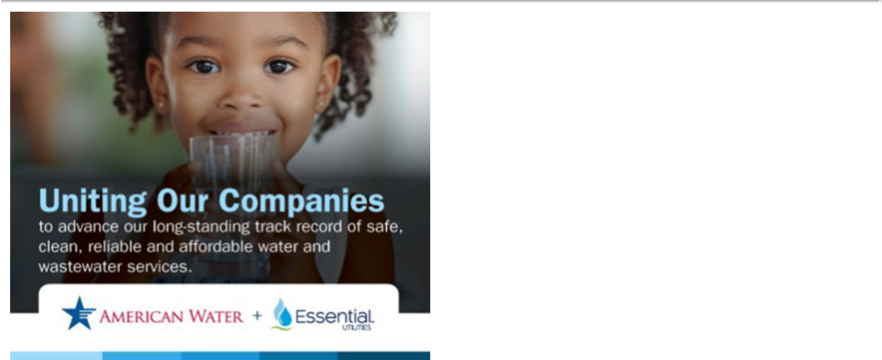

Cautionary Statement Regarding Forward-Looking Statements

Certain statements included in this communication are forward-looking statements within the meaning of Section 27A of the Securities Act of 1933, as amended, Section 21E of the Securities Exchange Act of 1934, as amended, and the Private Securities Litigation Reform Act of 1995. In some cases, these forward-looking statements can be identified by words with prospective meanings such as “intend,” “plan,” “estimate,” “believe,” “anticipate,” “expect,” “predict,” “project,” “propose,” “assume,” “forecast,” “outlook,” “future,” “likely,” “pending,” “goal,” “objective,” “potential,” “continue,” “seek to,” “may,” “can,” “will,” “should” and “could,” or the negative of such terms or other variations or similar expressions. Forward-looking statements may relate to, among other things: statements about the benefits of the proposed merger, including future financial and operating results; the parties’ respective plans, objectives, expectations and intentions; the expected timing and likelihood of completion of the merger and related transactions; the results of any strategic review; expected synergies of the proposed merger; the timing and result of various regulatory proceedings related to the proposed merger, and other general rate cases, filings for infrastructure surcharges and other governmental agency authorizations and proceedings, and filings to address regulatory lag; the combined company’s ability to execute its current and long-term business, operational, capital expenditures and growth plans and strategies; the amount, allocation and timing of projected capital expenditures and related funding requirements; the future impacts of increased or increasing transaction and financing costs associated with the proposed merger or otherwise, as well as inflation and interest rates; each party’s ability to finance current and projected operations, capital expenditure needs and growth initiatives by accessing the debt and equity capital markets and sources of short-term liquidity; impacts of the proposed merger on the future settlement or settlements of a party’s forward sale agreements, including potential adjustments to the forward sale price or other economic terms thereunder, and the amount of and the intended use of net proceeds from any such future settlement or settlements; the outcome and impact on other governmental and regulatory investigations; the filing of class action lawsuits and other litigation and legal proceedings related to the proposed merger; the ability to complete, and the timing and efficacy of, the design, development, implementation and improvement of technology and other strategic initiatives; each party’s ability to comply with new and changing environmental regulations; regulatory, legislative, tax policy or legal developments; and impacts that future significant tax legislation may have on each such party and on its business, results of operations, cash flows and liquidity.

These forward-looking statements are predictions based on currently available information, the parties’ current respective expectations and assumptions regarding future events that American Water Works Company, Inc. (“American Water”) and Essential Utilities, Inc. (“Essential Utilities”) believe to be reasonable. They are not, however, guarantees or assurances of any outcomes, performance or achievements, and readers are cautioned not to

place undue reliance upon them. You should not regard any forward-looking statement as a representation or warranty by American Water,

Essential Utilities or any other person that the expectation, plan or objective expressed in such forward-looking statement will be successfully achieved in any specified time frame, or at all. The forward-looking statements are subject to a number of estimates and assumptions, and known and unknown risks, uncertainties and other factors. Actual results may differ materially from those discussed in the forward-looking statements included in this communication as a result of the factors discussed in American Water’s Annual Report on Form 10-K for the year ended December 31, 2025, as filed with the Securities and Exchange Commission (the “SEC”) on February 18, 2026 (available at: ir.amwater.com), Essential Utilities’ Annual Report on Form 10-K for the year ended December 31, 2025, as filed with the SEC on February 26, 2026 (available at: essential.co), and each party’s other filings with the SEC, and additional risks and uncertainties, including with respect to (1) the parties’ ability to consummate the proposed merger pursuant to the terms of the definitive merger agreement or at all; (2) each party’s requirement to obtain required governmental and regulatory approvals required for the proposed merger (and/or that such approvals may result in the imposition of burdensome or commercially undesirable conditions, including required dispositions, that could adversely affect the combined company or the expected benefits of the proposed merger); (3) an event, change or other circumstance that could give rise to the termination of the merger agreement; (4) the failure to satisfy or waive a condition to closing of the proposed merger on a timely basis or at all; (5) a delay in the timing to consummate the proposed merger; (6) the failure to integrate the parties’ businesses successfully; (7) the failure to fully realize benefits, efficiencies and cost savings from the proposed merger or that such benefits, efficiencies and cost savings may take longer to realize or be more costly to achieve than expected; (8) negative or adverse impacts of the announcement of the proposed merger on the market price of American Water’s or Essential Utilities’ common stock; (9) the risk of litigation, legal proceedings or other challenges related to the proposed merger; (10) disruption from the proposed merger making it more difficult to maintain relationships with customers, employees, contractors, suppliers, regulators, vendors, elected officials, governmental agencies, or other stakeholders; (11) the diversion of each party’s management’s time and attention from ongoing business operations and opportunities of such party on merger-related matters; (12) the challenging macroeconomic environment, including disruptions in the water and wastewater utility industries; (13) the ability of each party to manage its respective existing operations and financing arrangements on favorable terms or at all, including with respect to future capital expenditures and investments, operations, and maintenance costs; (14) changes in environmental laws and regulations regarding each party’s respective operations that may adversely impact such party’s businesses or increase the cost of operations; (15) changes in each party’s key management and personnel; (16) changes in tax laws that could adversely affect beneficial tax treatment of the proposed merger; (17) regulatory, legislative, local or municipal actions affecting the water and wastewater industries, which could adversely affect the parties’ respective utility subsidiaries; and (18) other economic, business and other factors, including inflation, interest rate fluctuations or tariffs. The foregoing factors should not be construed as exhaustive.

These forward-looking statements are qualified by, and should be read together with, the risks and uncertainties set forth above and the risk factors included in American Water’s and Essential Utilities’ respective annual and quarterly reports as filed with the SEC and in the definitive joint proxy statement/prospectus, as filed with the SEC on December 31, 2025 (available at: https://www.sec.gov/Archives/edgar/data/1410636/000119312525337598/d15683d424b3.htm), and readers should refer to such risks, uncertainties and risk factors in evaluating such forward-looking statements. Any forward-looking statements speak only as of the date this communication is first used or given. Neither American Water nor Essential Utilities has any obligation or intention to update or revise any forward-looking statement, whether as a result of new information, future events, changed circumstances or otherwise, except as otherwise required by the federal securities laws. New factors emerge from time to time, and it is not possible for American Water or Essential Utilities to predict all such factors. Furthermore, it may not be possible to assess the impact of any such factor on American Water’s or Essential Utilities’ businesses, viewed independently or together, or the extent to which any factor, or combination of factors, may cause results to differ materially from those contained in any forward-looking statement.

Proposed Merger

For additional information regarding the proposed merger, please see American Water’s registration statement on Form S-4 (Registration No. 333-292182), which was declared effective by the SEC on December 30, 2025, and the other documents that American Water or Essential Utilities has filed or may file with the SEC.

No Offer or Solicitation

This communication is for informational purposes and is not intended to, and shall not, constitute an offer to sell or the solicitation of an offer to buy any securities, nor shall there be any offer or sale of securities in any jurisdiction in which such offer, solicitation or sale would be unlawful prior to registration or qualification under the securities laws of any such jurisdiction. No offering of securities shall be made except by means of a prospectus meeting the requirements of Section 10 of the Securities Act of 1933, as amended.

